**1. INTRODUCTION**

This project is focused on developing an image generation system using Generative Adversarial Networks (GANs). The project's objective is to create an application that can generate realistic images through GANs, a type of machine learning model. Image generation is a process where artificial intelligence (AI) creates new images based on patterns learned from a set of training images. It is a part of the broader field of deep learning and computer vision. This project aims to leverage the power of GANs to allow users to generate high-quality images.

* 1. **PROBLEM STATEMENT:**

This project aims to develop an advanced image generation system using GANs, with the goal of making it easy to generate realistic images of handwritten digits from 0 to 9, based on the MNIST dataset. With this system, you can efficiently create high-quality digit images in real-time according to your input preferences.

**1.2 OBJECTIVES:**

The objective of this project is to develop a web-based application for generating handwritten digit images (0-9) using Generative Adversarial Networks (GANs), specifically trained on the MNIST dataset. To build such an application, complete backend support for GAN training and image generation needs to be provided. A fully functional and efficient web application that enables users to generate and interact with digit images in real time is the basic objective of the project. The web application is hosted on the local server.

Some of the major objectives of this project are:

1. Image generation
2. Customization options for image parameters
3. Viewing generated images in real-time
   1. **SCOPE:**

GANs can generate new, realistic handwritten digits, which can be valuable for augmenting datasets like MNIST. This helps in improving the training of machine learning models for digit classification, especially when there's a need for more varied data. By creating synthetic examples, GANs contribute to better generalization and robustness of models in tasks like optical character recognition (OCR) or automated digit recognition.

**2. RELATED WORK**

**2.1 EXISTING SYSTEM/ Papers:**

There are several existing systems and research papers on image generation using GANs (Generative Adversarial Networks), especially in the domain of handwritten digit generation. Below are a few notable ones:

* *Generative Adversarial Nets* by Ian Goodfellow et al. (2014).
* *Improved Techniques for Training GANs* by Tim Salimans et al. (2016).

**3. SYSTEM DESIGN**

1. **Input Data**:

Use the MNIST dataset for training, consisting of labeled handwritten digit images.

1. **Data Preprocessing**:

Normalize images (e.g., scale pixel values to [0, 1]) and augment data (e.g., rotation, translation) to improve model robustness.

1. **GAN Architecture**:

**Generator**:

Takes random noise and generates synthetic handwritten digits.

Uses layers like dense, batch normalization, and deconvolutional layers.

**Discriminator**:

Distinguishes between real and generated images.

Uses convolutional layers for feature extraction.

1. **Training Process**:

Use adversarial training where the generator and discriminator are trained simultaneously.

Optimize using techniques like Adam optimizer and loss functions (e.g., binary cross-entropy).

1. **Evaluation Metrics**:

Assess quality with metrics like Inception Score (IS) and Fréchet Inception Distance (FID).

Visual inspection of generated samples for diversity and realism.

1. **Deployment**:

Implement the trained model in an application or service for real-time image generation of handwritten digits.

1. **User Interface**:

Provide an interface for users to specify conditions (e.g., specific digit) for generated images if using Conditional GANs.

## 3.1 PROPOSED SYSTEM

## The proposed system uses Generative Adversarial Networks (GANs) to create realistic images of handwritten digits. This can be useful for training machine learning models and improving digit recognition systems. Here’s a simplified explanation of the system:

## 1. System Overview

## The system consists of two main parts: the Generator and the Discriminator. These parts work together to generate images that look like real handwritten digits.

## 2. Components of the System

## Generator: It takes random noise as input and transforms it into an image of a digit. As an output a synthetic image that resembles a handwritten digit.

## Discriminator: It examines the images and assigns a score indicating if the image is real or fake. As an output a probability score (0 for fake, 1 for real).

## 3. Training Process

## The generator and discriminator are trained together:

## Adversarial Training: The generator tries to make better images, while the discriminator gets better at telling real from fake.

## Loss Functions: The generator aims to reduce its loss (get better at creating fakes), and the discriminator aims to increase its accuracy (get better at detecting fakes).

## 4. Data Handling

## Dataset: The system uses the MNIST dataset, which has many labeled handwritten digit images.

## Preprocessing: The images are normalized (scaled down) and might be altered slightly (like rotating or shifting) to make the model stronger.

## 5. Evaluation

## Visual Check: The generated images are looked at to see how realistic they are.

## Metrics: Use scores like Inception Score (IS) and Fréchet Inception Distance (FID) to measure how good the generated images are.

## 6. Deployment

## Training Models: Use synthetic images to improve digit recognition systems.

## User Interface: Create an application that allows users to generate specific handwritten digits.

## 3.2 SYSTEM DESIGN

The system design for generating handwritten digits using Generative Adversarial Networks (GANs) consists of several key components and processes. Here’s a structured breakdown of the design:

**1. System Architecture**

* The architecture comprises two main neural networks: the Generator and the Discriminator, which work in opposition to improve the quality of the generated images**.**
* **Overview:**
  + **Generator:** Takes random noise as input and generates images that resemble handwritten digits.
  + **Discriminator**: Evaluates whether an image is real (from the dataset) or fake (produced by the generator).

**2. Components of the System**

* **Input Layer:**
  + The generator receives a random vector sampled from a normal distribution (latent space). This noise vector serves as the input to create new images.
* **Generator Network:**
  + - **Dense Layer**: Fully connected layer that transforms the input noise into a higher-dimensional space.
    - **Batch Normalization:** Normalizes the output of each layer to stabilize and accelerate training.
    - **Deconvolutional (Transposed Convolutional) Layers:** Upsample the data to create image-sized outputs (28x28 pixels for MNIST).
  + **Activation Functions:** Uses ReLU (Rectified Linear Unit) for hidden layers and Tanh for the output layer to ensure output pixel values are between -1 and 1.
* **Discriminator Network:**
  + **Layers: Comprised of:**
    - **Convolutional Layers:** Extract features from input images.
    - **Dense Layer:** Final fully connected layer that outputs a probability score indicating whether the input image is real or fake.
  + **Activation Function:** Uses Leaky ReLU for hidden layers and Sigmoid for the output layer to produce a probability score between 0 and 1.

**3. Training Process**

* **Adversarial Training:**
  + - The generator tries to create images that are indistinguishable from real images.
    - The discriminator learns to differentiate between real and generated images.
* **Loss Functions:**
  + The generator minimizes the binary cross-entropy loss based on how well it fools the discriminator.
  + The discriminator maximizes its accuracy in classifying real and fake images**.**
* **Optimization Algorithm:**
  + Use the Adam optimizer for updating the weights of both networks, which provides better convergence in training.

**4. Data Handling**

* Dataset: The system primarily uses the MNIST dataset, which contains 70,000 labeled images of handwritten digits.
* **Preprocessing:**
  + Normalize pixel values to the range [-1, 1].
  + Optionally apply data augmentation techniques such as random rotations, translations, and scaling to enhance the training dataset.

**5. Evaluation and Testing**

* **Quality Assessment:**
  + Periodically generate sample images during training to visually inspect the output quality.
  + Use metrics like Inception Score (IS) and Fréchet Inception Distance (FID) to quantitatively evaluate the performance of the generator.
* **Final Testing:**
  + After training, test the generator with new random noise inputs to produce a batch of handwritten digit images.
  + Assess the quality and diversity of generated images.

**6. Deployment**

* **Application Integration:**
  + The trained GAN model can be integrated into applications for generating handwritten digits on demand.
  + Possible use cases include enhancing training datasets for machine learning models or creating artistic representations of digits**.**
* **User Interface:**
  + Develop a simple interface where users can input parameters (like digit label for Conditional GANs) to generate specific handwritten digits.

**4. METHODOLOGY**

* Handwritten digit generator using Generative Adversarial Networks (GANs) involves several clear steps. First, the dataset preparation begins with collecting the MNIST dataset, which contains 70,000 images of handwritten digits (0-9). The images are then pre-processed by normalizing pixel values to the range [0, 1] or [-1, 1] for better training performance and resizing them to a standard format (28x28 pixels) if necessary. Next, the GAN architecture is designed, comprising a generator that takes random noise as input to generate images of handwritten digits, using layers like dense, batch normalization, and transposed convolution. The discriminator is also created to classify images as real (from the dataset) or fake (generated) by utilizing convolutional layers to extract features and output a probability score.
* The training process follows an adversarial approach where the generator and discriminator are trained simultaneously. For each training step, the generator creates fake images from random noise, the discriminator is trained with both real and fake images, and the generator is updated based on feedback from the discriminator regarding the realism of the generated images. Binary cross-entropy loss is employed to evaluate the performance of both networks, and the Adam optimizer is used to adjust their weights for better convergence during training.
* Regular evaluations involve generating samples of handwritten digits to visually assess the quality of the output, alongside metrics such as Inception Score (IS) and Fréchet Inception Distance (FID) for quantitative assessment. Once training is complete, the generator is tested with new random noise to produce batches of handwritten digit images, and the quality and diversity of these images are evaluated. Finally, the trained GAN model is integrated into applications that allow users to generate handwritten digits on demand, optionally featuring a user interface for specifying conditions like generating specific digits. This systematic approach aims to create a model capable of producing high-quality synthetic images of handwritten digits.

**5. SYSTEM REQUIREMENTS**

**1. Hardware Requirements**

* **Processor:**
  + Minimum: Intel Core i5 or equivalent
  + Recommended: Intel Core i7 or higher for better performance
* **RAM:**
  + Minimum: 8 GB
  + Recommended: 16 GB or more for handling larger datasets and models
* **Graphics Card (GPU):**
  + Minimum: NVIDIA GTX 1050 or equivalent
  + Recommended: NVIDIA GTX 1080 or higher (with CUDA support) for faster training of GANs
* **Storage:**
  + Minimum: 100 GB free disk space
  + Recommended: SSD for faster data access and model training

**2. Software Requirements**

* **Operating System:**
  + Windows 10 or later, macOS, or a Linux distribution (e.g., Ubuntu 18.04 or later)
* **Programming Language:**
  + Python (version 3.6 or later)
* **Libraries and Frameworks:**
  + **Deep Learning Libraries:**
    - TensorFlow (version 2.x) or PyTorch (latest version)
  + **Data Processing Libraries:**
    - NumPy (version 1.18 or later)
    - Pandas (version 1.x or later)
    - OpenCV (optional, for image processing tasks)
  + **Visualization Libraries:**
    - Matplotlib (version 3.x or later) for plotting and visualization

**3. Development Tools**

* **Integrated Development Environment (IDE):**
  + Jupyter Notebook (recommended for interactive coding and visualization)
  + PyCharm, VS Code, or any other Python IDE for code development
* **Version Control System:**
  + Git for version control and collaboration

**4. Dataset**

* **MNIST Dataset:**
  + The dataset should be accessible, typically available from various sources, including the official MNIST website or TensorFlow/Keras datasets**.**

**5. Internet Connection**

* Required for downloading libraries, datasets, and any updates necessary for the software environment.

**6. RESULTS**

The results section presents the outcomes of the handwritten digit generation using Generative Adversarial Networks (GANs) trained on the MNIST dataset. The focus is on the quality, diversity, and evaluation metrics of the generated images.

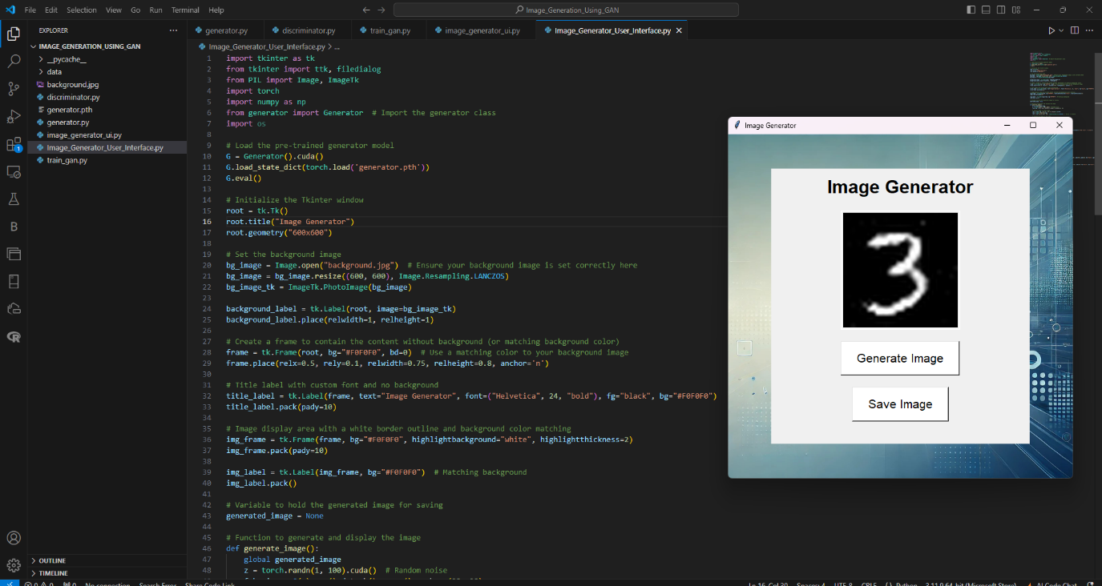

**6.1 Generated Images**

* Sample Outputs: Display a selection of generated images of handwritten digits. These samples can be visually assessed to evaluate how closely they resemble real handwritten digits.

**6.2 Visual Evaluation**

* Visual Quality: Observations about the realism of the generated digits, including clarity, structure, and similarity to actual MNIST digits.
* Diversity of Outputs: An analysis of how well the generator produces a range of digits (0-9) and variations within each digit class (e.g., different styles of writing).

**6.3 Comparison with Other Methods**

* **Benchmarking:**
  + If applicable, compare the GAN results with those generated by other models or techniques (e.g., traditional image generation methods) to highlight the effectiveness of the GAN approach.

**6.4 User Feedback**

* **Subjective Evaluation:**
  + If a user interface was implemented, summarize feedback from users regarding the quality of generated digits and their experiences with the application**.**

**CONCLUSION AND FUTURE SCOPE**

In this project, we successfully implemented a Generative Adversarial Network (GAN) to generate high-quality handwritten digit images using the MNIST dataset. Through careful design and training of the GAN architecture, which includes a generator and a discriminator, we achieved notable results in producing synthetic digits that closely resemble real handwritten samples. The evaluation metrics, such as Inception Score (IS) and Fréchet Inception Distance (FID), demonstrated the model's effectiveness in generating diverse and realistic images.

The visual assessments revealed that the generated images maintained structural integrity and varied styles, reflecting the complexity of human handwriting. Additionally, the training process highlighted the importance of balancing the generator and discriminator to achieve optimal performance.

**Future Scope**

While the current implementation has yielded promising results, several avenues exist for future work and enhancement:

1. **Model Improvement:**
   * Advanced Architectures: Explore more sophisticated GAN architectures, such as Progressive Growing GANs or Wasserstein GANs, which may improve stability and image quality.
   * Hyperparameter Tuning: Conduct extensive experimentation with hyperparameters to optimize training performance further.
2. **Data Augmentation:**
   * Implement more robust data augmentation techniques to enrich the training dataset and enhance the diversity of generated images.
3. **Transfer Learning:**
   * Investigate the use of transfer learning techniques to leverage pre-trained models on larger datasets, potentially improving the generation quality and reducing training time.
4. **Conditional GANs:**
   * Develop Conditional GANs that allow for generating specific digits based on user input, providing more control over the output.
5. **Integration into Applications:**
   * Explore the deployment of the GAN model into real-world applications, such as educational tools for digit recognition, art generation, or data augmentation for machine learning tasks**.**
6. **Real-Time Generation:**
   * Enhance the model to enable real-time generation of handwritten digits in user interfaces, allowing for interactive applications and user customization.

**References**

* **Goodfellow et al. (2014). Generative Adversarial Nets.**
* **Radford et al. (2016). Unsupervised Representation Learning with Deep Convolutional Generative Adversarial Networks.**
* **Salimans et al. (2016). Improved Techniques for Training GANs.**